Ideation Phase
Define the Problem Statements

Date | 25 August 2026
Project Name | Employee Raise Issues
Maximum Marks | 2 Marks

Customer Problem Statement Template:
Employees want a fair, transparent, and performance-based salary raise system, but inconsistent evaluation methods, unclear communication, and limited promotion opportunities make it difficult for them to understand or receive appropriate salary increments. As a result, employees feel demotivated, undervalued, and dissatisfied, which can reduce productivity and increase employee turnover.
The Employee Raise Issue project provides a simple and organized way for employees to submit their concerns. The issue is recorded, assigned to the appropriate department, and tracked until it is resolved.

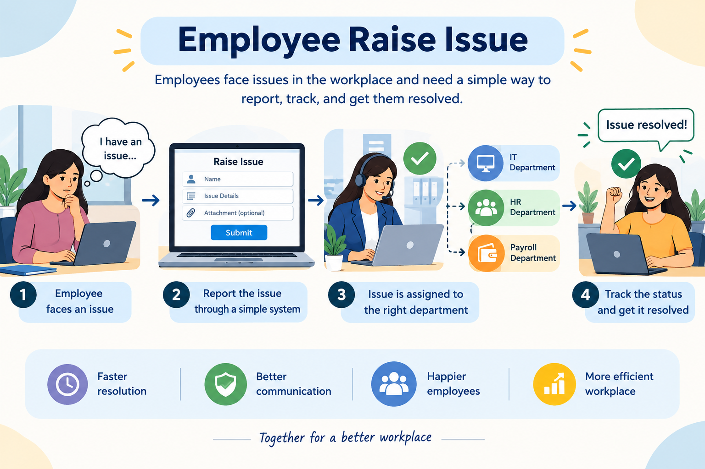
Example:-  PS-1  Field | Answer
I am (Customer) | An employee
I’m trying to | Report my workplace issues or concerns
But | I do not have a simple and organized way to submit and track my issues
Because | Issues are often reported through different methods such as messages, emails, or verbal communication
Which makes me feel | Frustrated and uncertain about whether my issue will be resolved

